**VISVESVARAYA TECHNOLOGICAL UNIVERSITY**

JNANA SANGAMA, BELAGAVI – 590 018



**An Internship Project Report**

**on**

***Flutter News Application***

Submitted in partial fulfilment of the requirements for the VIII Semester of degree of **Bachelor of Engineering in Information Science and Engineering** of Visvesvaraya Technological University, Belagavi

**Submitted By**

**Anagha**

**1RN18IS016**

**Under the Guidance of**

**Mrs Sunitha K**

**Assistant Professor**

**Department of ISE**



**Department of Information Science and Engineering**

**RNS Institute of Technology**

**Dr. Vishnuvaradhan Road, Rajarajeshwari Nagar post, Channasandra, Bengaluru-560098**

**2021-2022**

**RNS INSTITUTE OF TECHNOLOGY**

**Dr. Vishnuvaradhan Road, Rajarajeshwari Nagar post,**

**Channasandra, Bengaluru - 560098**

**DEPARTMENT OF INFORMATION SCIENCE AND ENGINEERING**



# **CERTIFICATE**

Certified that the Internship work entitled ***Flutter*** ***News Application*** has been successfully completed by **Anagha (1RN18IS016),** bonafide student of **RNS Institute of Technology, Bengaluru** in partial fulfilment of the requirements of 8th semester for the award of degree in **Bachelor of Engineering in Information Science and Engineering** of **Visvesvaraya Technological University, Belagavi** during academic year **2021-2022**. The internship report has been approved as it satisfies the academic requirements in respect of internship work for the said degree.

|  |  |  |
| --- | --- | --- |
| **____________________** | **_____________________** | **_____________________** |
| **Mrs. Sunitha K** | **Dr. Suresh L** | **Dr. M K Venkatesha** |
| Internship Guide | Professor and HoD | Principal |
| Assistant Professor | Department of ISE | RNSIT |
| Department of ISE | RNSIT |  |
|  |  |  |
|  | **External Viva** |  |
| **Name of the Examiners** |  | **Signature with Date** |
| **1.** | | **1.** |
| **2. ___________________________** | | **2. ______________________** |

# **DECLARATION**

I, **Anagha [USN: 1RN18IS016]** student of VIII Semester BE, in Information Science and Engineering, RNS Institute of Technology hereby declare that the Internship work entitled ***Flutter News Application*** has been carried out by us and submitted in partial fulfilment of the requirements for the *VIII Semester degree of* ***Bachelor of Engineering in Information Science and Engineering*** *of Visvesvaraya Technological University, Belagavi* during academic year 2021-2022.

Place: Bengaluru

Date: 13/01/2022 **Anagha (1RN18IS016)**

# **ABSTRACT**

The purpose of Flutter News Application is to automate the existing manual system with the help of computerized equipment and deliver full-fledged working software, fulfilling their news service requirements, so that their valuable data can be stored for a longer duration with ease of access and manipulation if needed. The required software and hardware are easily available and easy to work.

News Application, as described above, can lead to error free, secure, reliable and fast news management systems. It can assist the user to concentrate on news available rather than worry about how to store it. Thus, it will help the users in better utilization of resources and platform to access the services. The users can maintain computerized records without losing files or information loss. Also, that means that one need not be distracted by information that is not relevant, while being able to reach the information.

Basically, the project describes news data available with ease and have good performance and better services for the users. The single application which caters all the details of services along with detailed description that are offered to the end users. The existing application has been enhanced to make the application user friendly with various operations.

# **ACKNOWLEDGMENT**

At the very onset we would like to place our gratefulness to all those people who helped me in making the Internship a successful one.

Coming up, this internship to be a success was not easy. Apart from the sheer effort, the enlightenment of the very experienced teachers also plays a paramount role because it is, they who guided me in the right direction.

First of all, I would like to thank the **Management of RNS Institute of** **Technology** for providing such a healthy environment for the successful completion ofinternship work.

In this regard, I express sincere gratitude to our beloved Principal **Dr. M K Venkatesha,** for providing us all the facilities.

We are extremely grateful to our own and beloved Professor and Head of Department of Information science and Engineering, **Dr. Suresh L**, for having accepted to patronize me in the right direction with all her wisdom.

We place our heartfelt thanks to Mrs. **Sunitha K** Assistant Professor, Department of Information Science and Engineering for having guided internship and all the staff members of the department of Information Science and Engineering for helping at all times.

I thank **Mr. Akshay D R, Founder, Enmaz**, for providing the opportunity to be a part of the Internship program and having guided me to complete the same successfully.

I also thank our internship coordinator **Dr. R Rajkumar,** Associate Professor, Department of Information Science and Engineering. I would thank my friends for having supported me with all their strength and might. Last but not the least, I thank my parents for supporting and encouraging me throughout. I have made an honest effort in this assignment.

# **TABLE OF CONTENTS**

|  |  |
| --- | --- |
| **Abstract** | **i** |
| **Acknowledgment** | **ii** |
| **Contents** | **iii** |
| **List of tables** | **vii** |
| **List of figures** | **viii** |
| **List of Abbreviations** | **ix** |
| **1. Introduction** | **10** |
| 1.1 Background | 11 |
| 1.2 Requirements | 12 |
| **2. Literature Review** | **13** |
| **3. Analysis** | **16** |
| **4. System Design** | **19** |
| 4.1 Current Design | **19** |
| 4.2 Proposed Design | **19** |
| **5**. **Detailed Design** | **21** |
| 5.1 Widget tree | **21** |
| 5.2 Database Table description | **24** |
| **6. Implementation** | **25** |
| 6.1 Introduction | **25** |
| 6.2 Overview of system implementation and tools | **27** |
| 6.3 Implementational support | **29** |
| 6.4 Code Segment | **31** |
| **7. Testing** | **38** |
| 7.1 Testing for development | **39** |
| 7.2 Testing for user authentication | **40** |
| **8. Results** | **43** |
| **9. Conclusion and future enhancements** | **52** |
| **References** | **53** |

# **List of Figures**

|  |  |  |
| --- | --- | --- |
| **Fig. No.** | **Figure Description** | **Page No.** |
| 2.1 | Flutter History | 14 |
| 2.2 | Flutter Trees Relationship | 14 |
| 3.1 | Flutter Architecture | 17 |
| 4.1 | Current Design | 19 |
| 4.2 | Proposed Design | 20 |
| 5.1 | Home page widget tree | 21 |
| 5.2 | Article page widget tree | 22 |
| 5.3 | Category news page widget tree | 23 |
| 8.1 | Sign-In page | 43 |
| 8.2 | Home page | 44 |
| 8.3 | Health page | 45 |
| 8.4 | Science page | 46 |
| 8.5 | Sports page | 47 |
| 8.6 | Technology page | 48 |
| 8.7 | Health Web View | 49 |
| 8.8 | Sports Web View | 50 |
| 8.9 | Entertainment Web View | 51 |

# **List of Tables**

|  |  |  |
| --- | --- | --- |
| **Table No.** | **Description of the Table** | **Page No.** |
| **3.2.1** | Users Table | 24 |
| **3.2.2** | News Table | 24 |
| **3.2.3** | Source News Table | 24 |
| **3.2.4** | Testing table for development | 39 |
| **3.2.5** | Testing table for user authentication | 40 |

# **ABBREVIATIONS**

|  |  |
| --- | --- |
| **Acronym** | **Description** |
| HTML | Hypertext Markup Language |
| CSS | Cascading Style Sheets |
| IE | Internet Explorer |
| ISO | International Organization of Standardization |
| ANSI | American National Standard Institutes |
| IDE | Integrated development environment |
| VS | Visual Studio |
| SDK | Software development kit |
| UI | User interface |

# **CHAPTER** **1**

# **INTRODUCTION**

Flutter is an open-source UI software development kit created by Google. It is used to develop cross platform applications for Android, iOS, Linux, Mac, Windows, Google Fuchsia, Web platform, and the web from a single codebase.

Flutter is a boon for developers who want to build a wide range of applications on the dart programming language to build hybrid mobile applications. It is thus considered a powerful programming framework and features in every developer’s cache of tools.

Dart is a programming language developed by google for client development, such as mobile and web apps. It can also be used to build server and desktop applications. It is an object-oriented language with C like syntax.

The following are a few of the applications that use flutter

* Google Ads
* KlasterMe
* Reflecty

**Merits of dart:**

* Being an object-oriented language, dart allows you to create modular, maintainable applications and reusable codes.
* Easy to develop as it has a rich class of libraries for smooth implementation of functions.
* Enhanced integration as an application written in flutter will integrate and interpret better when compared to other mobile technologies
* Dart is compiled fast and is reliable. Due to it being type safe it prevents a lot of errors and exceptions beforehand, helping developers to fix the bugs.
* It’s safe, with no data loss as there is no type-conversion so that you can write secure codes.
* Dark has a strong community of developers who are actively working on making it better and is a perfect choice for new comers.

# **Background**

The "News Application" has been developed to override the problems prevailing in the practicing manual system. This software is supported to eliminate and, in some cases, reduce the hardships faced by this existing system. Moreover, this system is designed for the need of the users to carry out operations in a smooth and effective manner.

The application is reduced as much as possible to avoid errors while entering the data. No formal knowledge is needed for the user to use this system. Thus, by this all it proves it is user-friendly. News Application, as described above, can lead to error free, secure, reliable and fast news management system. It can assist the user to concentrate on their news rather than concentrating on the record keeping. Thus, it will help users in better utilization of resources.

Everyone has challenges to overcome and manage the information of Car, Education, Tourist Location, Payment and other news that they have to read and manage the overwhelming amount of information. This system is designed to assist in strategic planning and will help you ensure that users are equipped with the right level of information and details for their future goals. Also, for those busy executives who are always on the go. Our systems come with remote access features, which will allow the users to manage their news anytime, always. These systems will ultimately allow them to better manage news information.

It helps in saving time of users as it also provides them to group news by category and view more information only related to it. It scales to a good number of users and can be used by android and iPhone users.

Our project aims at News automation, i.e., we have tried to gather and present various categories of the news and make News Application.

# 

# **1.2. Requirements**

1.2.1 Software Requirements

|  |  |
| --- | --- |
| **Name of Components** | **Specification** |
| Operating System | Windows 10 |
| Language | Dart |
| Browser | Chrome, Android simulator |
| Integrated Development Environment | Microsoft Visual Studio Code |

1.2.2 Hardware Requirements

|  |  |
| --- | --- |
| **Name of Components** | **Specification** |
| Processor | 10TH Gen CORE i7 Processor |
| RAM | 8GB |
| Hard Disk | 512 GB SSD |

# **Chapter 2**

# **Literature Review**

Flutter is an open-source mobile SDK developer can use to build native-looking Android and iOS applications from the same code base. Flutter has been around since 2015 when Google introduced it and remained in the beta stage before its official launch in December 2018. Since then, the buzz around Flutter has been growing stronger. Flutter is now the top 11 software repos based on GitHub stars. Moreover, we have already seen thousands of Flutter apps being published on app stores.

Flutter – a simple and high-performance framework based on Dart language, provides high performance by rendering the UI directly in the operating system’s canvas rather than through native framework. Flutter also offers many ready to use widgets (UI) to create a modern application. These widgets are optimized for mobile environment and designing the application using widgets is as simple as designing HTML. To be specific, Flutter application is itself a widget.

Flutter widgets also supports animations and gestures. The application logic is based on reactive programming. Widget may optionally have a state. By changing the state of the widget, Flutter will automatically (reactive programming) compare the widget’s state (old and new) and render the widget with only the necessary changes instead of re-rendering the whole widget

**Features of Flutter**

➢ Flutter framework offers the following features to developers

➢ Modern and reactive framework.

➢ Uses Dart programming language and it is very easy to learn.

➢ Fast development.

➢ Beautiful and fluid user interfaces.

➢ Huge widget catalogue.

➢ Runs same UI for multiple platforms.

➢ High performance application

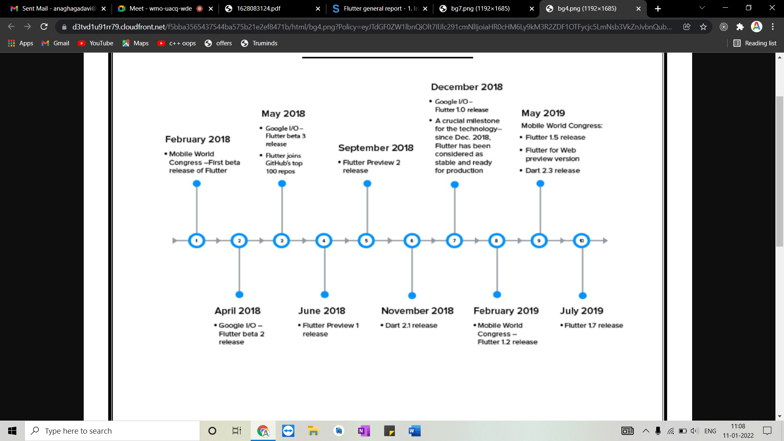

Figure 2.1 Flutter history

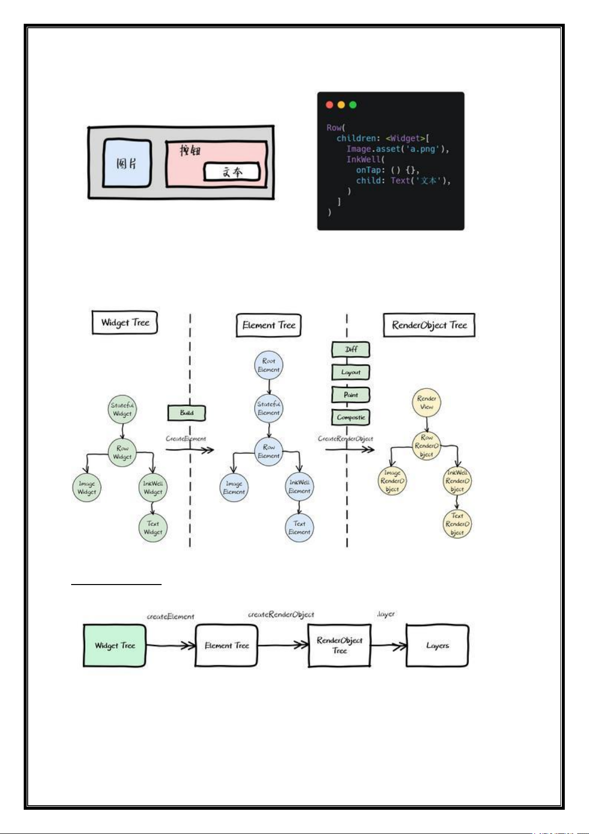

Figure 2.2 flutter trees

The first tree is the Widget Tree. It is the basic logical unit of control implementation, and is how users describe the interface UI.

Flutter interface development is a kind of responsive programming, advocating "simple is fast", and re-creating the Widget Tree from top to bottom to refresh, this idea is relatively simple, without additional relationship data changes will affect which nodes.

The second tree, Element Tree. It is the instantiated object of Widget (as shown below, Widget provides createElementFactory method to create Element), which persists in the Dart context at runtime. It carries the constructed context data and is the bridge connecting the structured configuration information to the final rendering. The reason why it persists in the context of Dart instead of rebuilding like Widget, because the cost of re-creating and re-rendering of Element Tree will be very large, so Element Tree to RenderObject Tree also has a Diff link to calculate the minimum redraw area.

The third tree, RenderObject Tree, is the render object tree. RenderObject is created by Element and linked toElement. renderObjectOn, it accepts Element's information synchronization. Similarly, it is also persistently stored in the context of Dart Runtime, and is mainly responsible for implementing view rendering.

# **CHAPTER 3**

# **Analysis**

**Fast development** Flutter engineered for high development velocity. Stateful hot reload allows you to change your code and see it come to life is less than a second without losing the state of the app. Flutter also ships with a rich set of customizable widgets, all built from modem reactive framework.

**Expressive + Flexible UI** Flutter moves to a widget, rendering, animation and gestures into this framework to give you to complete control over every pixel on the screen. It means you have the flexibility to build a custom design.

**Native apps for Android and IOS**: Flutter apps follow platform conventions and interface details such as scrolling, navigation, icons, fonts, etc. That why apps built with Flutter features on both APP STORE and GOOGLE PLAY STORE.

**Hot Reload**: In flutter, very save on the app and just as you do on the web just hit a refresh and your codes also refresh. Imaging that Facebook SDK it would be so humongous if it would have been designing android and you hit a recompile. So many things to have recompile and it would take probably days. Unmistakably, Hot reloading is tech which is kind of necessary when your applications or product goes like incense crazy like Facebook

**High Performance**: Flutter doesn’t require a JavaScript bridge and the speed is much faster.

**Using Dart as a Programming Language:** Dart is an object-oriented programming language that which used for writing mobile application code for Flutter and which contributes to the efficiency and effectiveness of app development flow. It is a comfortable language and uses a lot of CSS parts as well. Dart uses for generational garbage collection which helps in creating frames for short-lived objects.

**Reduce the Third Parties**: When using flutter, you cn get complete IOS experience or Android Experience. So, they are reducing the Third parties.

**API:** The Flutter API is very consistent, Animation Builder, Future Builder, Stream Builder,…Once you understand them you have no limit. Anything is a widget. A button can use as a screen, a full page used as a button with animation and transformation.

**The customizable kit of Widgets**: Flutter has built with a rich and customizable set of widgets for Android, IOS and Material Design. The collaboration between Flutter and Google’s material design has rendered and easily create powerful UI experience. This help to create smooth, crisp and refined app experience as are available with a native app.

**Flutter Architecture**

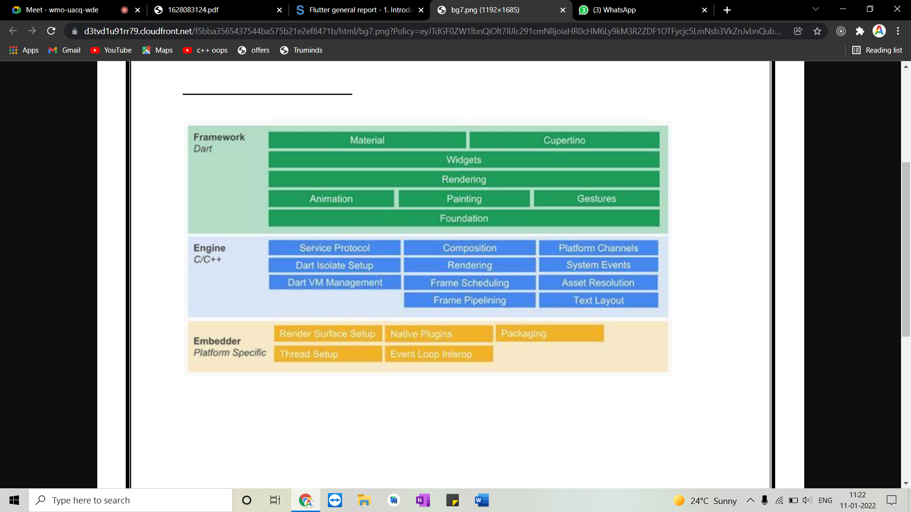

Figure 3.1 Flutter architecture

Flutter includes a modern react-style framework, a 2D rendering engine, ready-made widgets, and development tools. These components work together to help you design, build, test, and debug apps. Everything is organized around a few core principles.

Traditional conventions, as long as the article about the principle of Flutter, this picture will be placed at the beginning. Regardless of whether it is good or not, it is first put forward, and most of them still rely on their own understanding. Because this picture is so easy to use. Putting this picture out, it is still simple to understand what is Flutter from the whole, otherwise it is easy to fall into the "blind person to touch the elephant" situation.

2. Engine◦: Realize functions such as FLutter rendering engine, text

layout, event processing, and Dart runtime. Including Skia graphics

drawing library, Dart VM, Text, etc., among which Skia and Text

provide the ability to call the underlying rendering and typesetting for

the upper layer interface.

3. Framework：It is a UI SDK implemented with Dart. From top to

bottom, it includes two major style component libraries, basic

component libraries, graphics drawing, gesture recognition, animation

and other functions.

2. Engine◦: Realize functions such as FLutter rendering engine, text

layout, event processing, and Dart runtime. Including Skia graphics

drawing library, Dart VM, Text, etc., among which Skia and Text

provide the ability to call the underlying rendering and typesetting for

the upper layer interface.

3. Framework：It is a UI SDK implemented with Dart. From top to

bottom, it includes two major style component libraries, basic

component libraries, graphics drawing, gesture recognition, animation

and other functions.

Traditional conventions, as long as the article about the principle of Flutter, this picture will be

placed at the beginning. Regardless of whether it is good or not, it is first put forward, and most

of them still rely on their own understanding. Because this picture is so easy to use.

Putting this picture out, it is still simple to understand what is Flutter from the whole, otherwise

it is easy to fall into the "blind person to touch the elephant" situation.

Traditional conventions, as long as the article about the principle of Flutter, this picture will be

placed at the beginning. Regardless of whether it is good or not, it is first put forward, and most

of them still rely on their own understanding. Because this picture is so easy to use.

Putting this picture out, it is still simple to understand what is Flutter from the whole, otherwise

it is easy to fall into the "blind person to touch the elephant" situation.

Traditional conventions, as long as the article about the principle of Flutter, this picture will be

placed at the beginning. Regardless of whether it is good or not, it is first put forward, and most

of them still rely on their own understanding. Because this picture is so easy to use.

Putting this picture out, it is still simple to understand what is Flutter from the whole, otherwise

it is easy to fall into the "blind person to touch the elephant" situation.

Traditional conventions, as long as the article about the principle of Flutter, this picture will be

placed at the beginning. Regardless of whether it is good or not, it is first put forward, and most

of them still rely on their own understanding. Because this picture is so easy to use.

Putting this picture out, it is still simple to understand what is Flutter from the whole, otherwise

it is easy to fall into the "blind person to touch the elephant" situation.

Traditional conventions, as long as the article about the principle of Flutter, this picture will be

placed at the beginning. Regardless of whether it is good or not, it is first put forward, and most

of them still rely on their own understanding. Because this picture is so easy to use.

Putting this picture out, it is still simple to understand what is Flutter from the whole, otherwise

it is easy to fall into the "blind person to touch the elephant" situation.

Traditional conventions, as long as the article about the principle of Flutter, this picture will be

placed at the beginning. Regardless of whether it is good or not, it is first put forward, and most

of them still rely on their own understanding. Because this picture is so easy to use.

Putting this picture out, it is still simple to understand what is Flutter from the whole, otherwise

it is easy to fall into the "blind person to touch the elephant" situation.

The Flutter architecture uses a layered design, which is divided into three layers from bottom to top, in this order: Embedder, Engine, Framework.

* Embedder：Operating system adaptation layer to realize rendering Surface settings, thread settings, etc.
* Engine◦: Realize functions such as Flutter rendering engine, text layout, event processing, and Dart runtime. Including Skia graphics drawing library, Dart VM, Text, etc., among which Skia and Text provide the ability to call the underlying rendering and typesetting for the upper layer interface.
* Framework：It is a UI SDK implemented with Dart. From top to bottom, it includes two major style component libraries, basic component libraries, graphics drawing, gesture recognition, animation and other functions.

**Google** **Firebase**

**Firebase** is a Backend-as-a-Service (Baas). It provides developers with a variety of tools and services to help them develop quality apps, grow their user base, and earn profit. It is built on Google’s infrastructure. Firebase is categorized as a [NoSQL](https://www.educative.io/edpresso/whats-the-difference-betweensql-and-nosql) database program, which stores data in JSON-like documents.

**Key Features:**

* Authentication
* Real-Time Database
* Hosting
* Notifications

# **CHAPTER 4**

# **SYSTEM DESIGN**

# **4.1. Current Design**

The current application consisted only of user accessing and seeing the small quantity of news available with generic topics, about page, some sports news and mostly promotional content for the application. The ads hinder the user experience and makes them switch platforms.

User can access

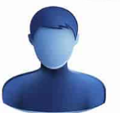

**HOME || ABOUT || SPORTS**

News

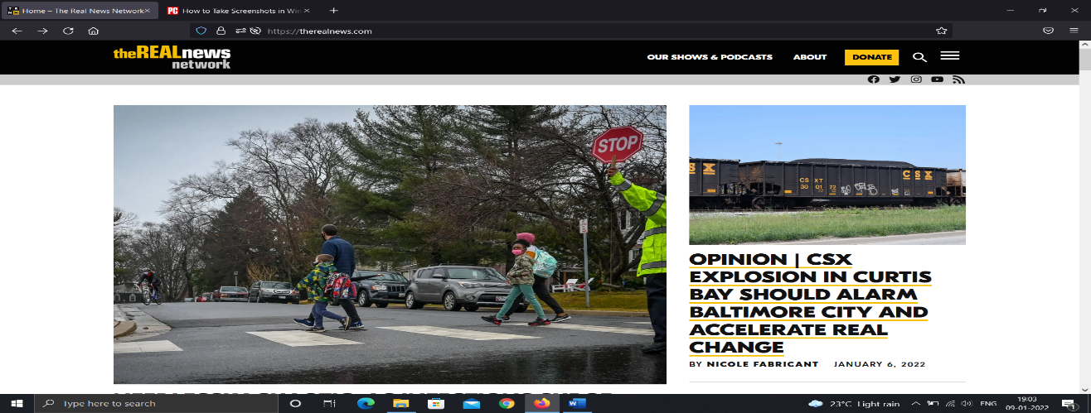

Figure 4.1: Existing news system

# **4.2. Proposed Design**

The existing web application has been enhanced to make the application more interactive and make user friendly with add-on functionalities. The features like Home, sports, health, science, business and technology news options for the client. The option to select a topic has been integrated easily and the user can view it in detail as he will be redirected to the site containing more information. The Home, Sports, Science etc sections are enhanced with dynamic data to provide better details of each service and its offerings.



User registration

User Login

User Access -> News

**HOME || Sports || Business || Health** || **General || Science**

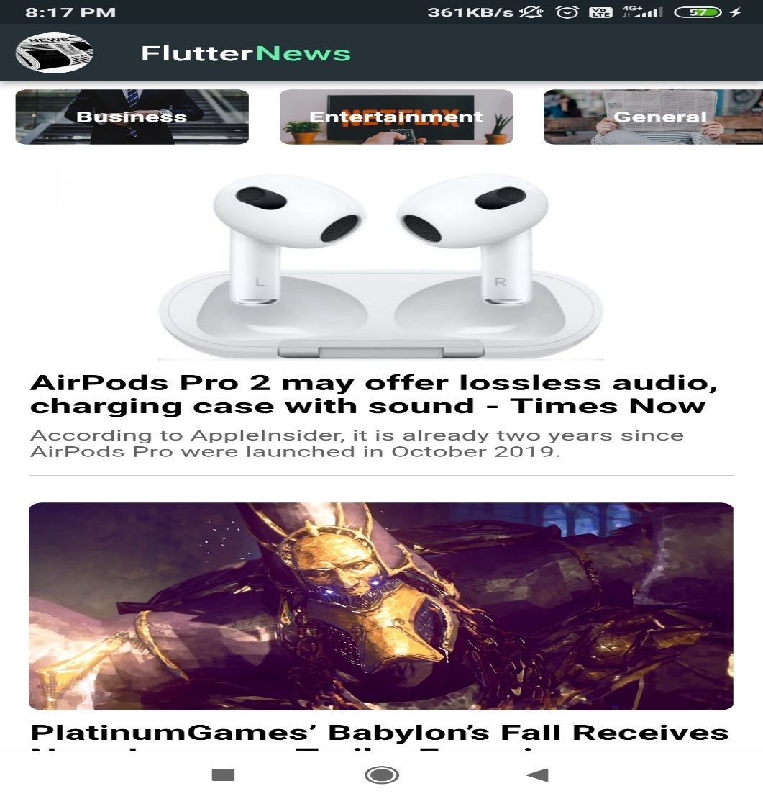

Figure 4.2: Proposed News system

# **CHAPTER 5**

# **DETAILED DESIGN**

# **5.1 Widget tree**

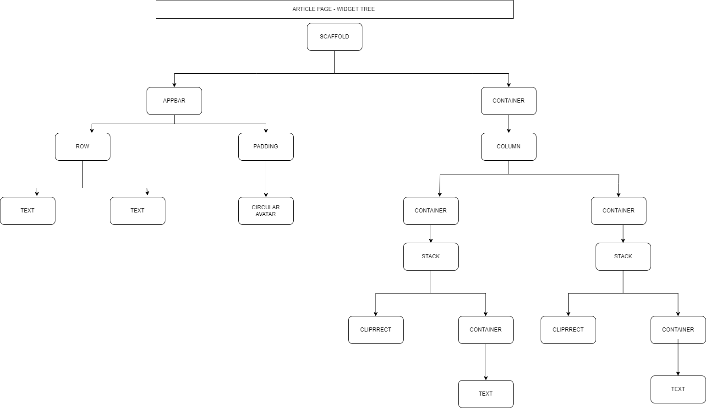

Figure 5.1. Home page widget tree

The above tree is a diagrammatic representation of the home page which consists of appbar for navigation, containers for generic news.

**Article page tree**

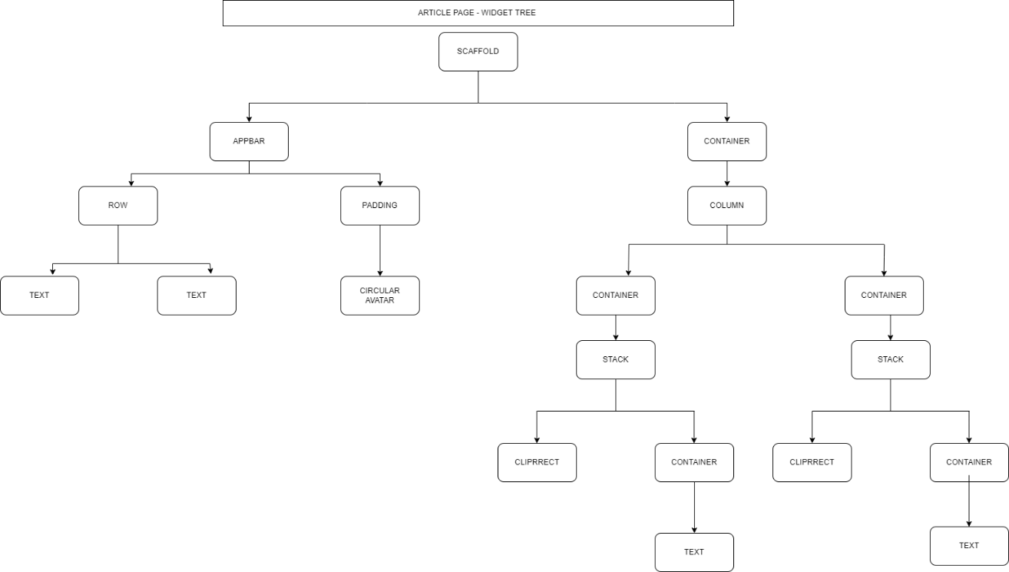

Figure 5.2 Widget tree of article page

The above tree shows the article page with components that are reused from the homepage. This reusability reduces the bugs and makes it efficient to develop.

**Category page Tree**

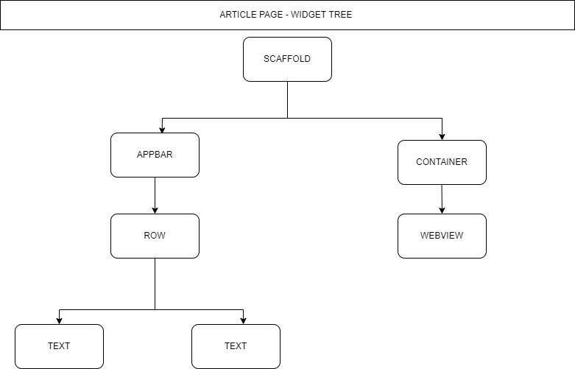

Figure 5.3 Widget tree of category news page

The above tree shows the general architecture of how a news page will be laid out. When a user clicks on a news for detail, he will be redirected to the official website called WebView to get more details.

# **5.2 DATABASE TABLE DESCRIPTION**

**5.2.1 Users**:

|  |  |  |  |  |  |
| --- | --- | --- | --- | --- | --- |
| **Uid** | **isAnonymous** | **ProviderId** | **CreationTime** | **LastSignInTime** | **IsEmailVerified** |
| 1 | false | firebase | 156974482357 | 15928445141358 | True |
| 2 | false | firebase | 156974482389 | 15928445141390 | False |

Table 5.2.1 User’s table

**5.2.2 News**:

|  |  |  |  |  |  |  |
| --- | --- | --- | --- | --- | --- | --- |
| **Author** | **Title** | **Description** | **Url** | **ImgUrl** | **PublishedAt** | **SourceId** |
| noreply@blogger.com | Bitcoin | Elon Musk reveals who bitcoin's creator Satoshi Nakamoto might be | https://techncruncher.blogspot.com | https://blogger.googleusercontent.com/img | 2021-12-29T20:41:00Z | engadget |
| Shoshana Wodinsky | Crypto Dev | crypto community have set a high bar for devising the worst ways to hawk | https://gizmodo.com/ | https://i.kinja-img.com/ | 2022-01-07T19:30:00Z | reuters |

Table 5.2.2 News table

**3.Source**:

|  |  |
| --- | --- |
| **SourceId** | **SourceName** |
| engadget | Engadget |
| reuters | Reuters |

Table 5.2.3 Source table

# **CHAPTER 6**

# **IMPLEMENTATION**

# **6.1 INTRODUCTION**

The application is built using flutter framework. It has its own style of mentioning buttons, forms, dropdowns, navigation. It comes with a customer way of styling the pages using built-in widgets. The programming languages it uses is called dart. It makes an api call to a backend built on a remote host to get the live news data.

**6.1.1. Flutter**

The Flutter framework consists of both a software development kit (SDK) and their widget-based UI library. This library consists of various reusable UI elements, such as sliders, buttons, and text inputs.

Developers building mobile applications with the Flutter framework will do so using a programming language called Dart. With a syntax like JavaScript, Dart is a typed object programming language that focuses on front-end development.

Although Flutter is a newer cross-platform framework, more and more companies have chosen Flutter over frameworks such as Xamarin, Cordova, and React Native.

Some of the top reasons why development teams choose Flutter include:

* **Increased productivity.** Using the same codebase for iOS and Android saves both time and resources. Flutter’s native widgets also minimize time spent on testing by ensuring there is little to no compatibility issues with different OS versions.
* **Easy to learn.** Flutter allows developers to build native mobile applications without needing to access OEM widgets or use a lot of code. This, in addition to Flutter’s particularly appealing user interface, makes the mobile app creation process much simpler.
* **Great performance.** Users report that it is difficult to notice the difference between a Flutter app and a native mobile app.
* **Cost-effective.** Building iOS and Android apps with the same codebase is essentially building two apps for the price of one.
* **Available on different IDEs.** Developers are free to choose between Android Studio and VS Code to edit their code on Flutter.
* **Great documentation & community.** Flutter has many great resources to answer your questions, thanks to its ample documentation with easy-to-follow use cases.

**6.1.2 Dart**

Dart is a programming language. And programming languages can be, as it turns out, hard to learn. The fundamentals of Dart are similar to all higher-level languages. You'll find familiarity in Dart syntax if you're coming from JavaScript, Java, or any other C-like language. You'll feel comfortable with Dart's object-oriented design if you're coming from Ruby or Python.

Dart excels at being a "safe" language to learn. Google didn't set out to create anything innovative with Dart. Google wanted to make a language that was simple and productive and that could be compiled into JavaScript. What Google came up with, it turns out, works well for writing UIs.

Dart is an object-oriented, class defined, single inheritance language using a C-style syntax that trans compiles optionally into JavaScript. It supports interfaces, mixins, abstract classes, reified generics, optional typing, and a sound type system.

**6.1.3 API**

What does API stand for? Application Programming Interface, and it includes three important elements:

**1. Procedures**

Also referred to as routines, procedures refer to the specific tasks or functions a program performs. For example, Twitter provides a search API for developers to explore data for analytical purposes.

**2. Protocols**

The protocol is the format used to communicate data between applications. This can get complicated, though. Applications may not rely on the same format. But, more on this later.

**3. Tools**

Think of tools as a set of building blocks – the components needed to construct new programs.

APIs are needed to bring applications together in order to perform a designed function built around sharing data and executing pre-defined processes.

They work as the middle man, allowing developers to build new programmatic interactions between the various applications people and businesses use on a daily basis.

# **6.2 OVERVIEW OF SYSTEM IMPLEMENTATION AND TOOLS**

Below mentioned are the tool used to code and test the application. It works on both android and iOS applications and flutter is hybrid framework.

**6.2.1 VS Code**

**Visual Studio Code** (famously known as **VS Code**) is a free open-source text editor by Microsoft. VS Code is available for Windows, Linux, and macOS. Although the editor is relatively lightweight, it includes some powerful features that have made VS Code one of the most popular development environment tools in recent times.

.NET is a free, cross-platform, open-source developer platform for building many different types of applications. With .NET, you can use multiple languages, editors, and libraries to build for web, mobile, desktop, games, and IoT..NET is a software framework that is designed and developed by Microsoft. The first version of the .Net framework was 1.0 which came in the year 2002. In easy words, it is a virtual machine for compiling and executing programs written in different languages like [C#](https://www.geeksforgeeks.org/introduction-to-c/), VB.Net, etc.

The VS Code user interface allows for a lot of interaction compared to other text editors. To simplify user experience, VS Code is divided into five main regions:

* The activity bars
* The side bars
* Editor groups
* The panel
* The status bars

**6.2.2 Android SDK**

The Android SDK is a collection of software development tools and libraries required to develop Android applications. Every time Google releases a new version of Android or an update, a corresponding SDK is also released which developers must download and install. It is worth noting that you can also download and use the Android SDK independently of Android Studio, but typically you'll be working through Android Studio for any Android development.

The Android SDK comprises all the tools necessary to code programs from scratch and even test them. These tools provide a smooth flow of the development process from developing and debugging, through to packaging.

The Android SDK is compatible with Windows, macOS, and Linux, so you can develop on any of those platforms.

6.2.3 **IOS SDK**

The **iOS SDK** (**iOS Software Development Kit**), formerly the **iPhone SDK**, is a software development kit (SDK) developed by Apple Inc. The kit allows for the development of mobile apps on Apple's iOS and iPadOS operating systems.

The iOS SDK is a free download for users of Macintosh (or Mac) personal computers. It is not available for Microsoft Windows PCs. The SDK contains sets giving developers access to various functions and services of iOS devices, such as hardware and software attributes. It also contains an iPhone simulator to mimic the look and feel of the device on the computer while developing. New versions of the SDK accompany new versions of iOS. In order to test applications, get technical support, and distribute apps through App Store, developers are required to subscribe to the Apple Developer Program.

# **6.3 IMPLEMENTATION SUPPORT**

6.3.1 **Flutter Installation**

* Download the installation bundle on the website: <https://docs.flutter.dev/get-started/install/windows>
* Extract the zip file and place the contained flutter in the desired installation location for the Flutter SDK (for example, C:\Users\<your-user-name>\Documents).
* From the Start search bar, enter ‘env’ and select Edit environment variables for your account.
* Under User variables check if there is an entry called Path:

1. If the entry exists, append the full path to flutter\bin using; as a separator from existing values.
2. If the entry doesn’t exist, create a new user variable named Path with the full path to flutter\bin as its value C:\src\flutter>flutter doctor.

6.3.2 **Android Installation**

* **Install Android Studio**

1. Download and install Android Studio.
2. Start Android Studio, and go through the ‘Android Studio Setup Wizard’. This installs the latest Android SDK, Android SDK Command-line Tools, and Android SDK Build-Tools, which are required by Flutter when developing for Android.
3. Run flutter doctor to confirm that Flutter has located your installation of Android Studio. If Flutter cannot locate it, run flutter config --android-studio-dir <directory> to set the directory that Android Studio is installed to.

6.3.3 **Set up Android device**

To prepare to run and test your Flutter app on an Android device, you need an Android device running Android 4.1 (API level 16) or higher.

1. Enable Developer options and USB debugging on your device. Detailed instructions are available in the [Android documentation](https://developer.android.com/studio/debug/dev-options).
2. Windows-only: Install the [Google USB Driver](https://developer.android.com/studio/run/win-usb).
3. Using a USB cable, plug your phone into your computer. If prompted on your device, authorize your computer to access your device.

In the terminal, run the flutter devices command to verify that Flutter recognizes your connected Android device. By default, Flutter uses the version of the Android SDK where your adb tool is based. If you want Flutter to use a different installation of the Android SDK, you must set the ANDROID_SDK_ROOT environment variable to that installation directory.

6.3.4 **Set up Android emulator**

To prepare to run and test your Flutter app on the Android emulator, follow these steps:

1. Enable [VM acceleration](https://developer.android.com/studio/run/emulator-acceleration) on your machine.
2. Launch Android Studio, click the AVD Manager icon, and select Create Virtual Device…
   * In older versions of Android Studio, you should instead launch Android Studio > Tools > Android > AVD Manager and select Create Virtual Device…. (The Android submenu is only present when inside an Android project.)
   * If you do not have a project open, you can choose Configure > AVD Manager and select Create Virtual Device…
3. Choose a device definition and select Next.
4. Select one or more system images for the Android versions you want to emulate, and select Next. An *x86* or *x86_64* image is recommended.
5. Under Emulated Performance, select Hardware - GLES 2.0 to enable [hardware acceleration](https://developer.android.com/studio/run/emulator-acceleration).
6. Verify the AVD configuration is correct, and select Finish.  
   For details on the above steps, see [Managing AVDs](https://developer.android.com/studio/run/managing-avds).
7. In Android Virtual Device Manager, click Run in the toolbar. The emulator starts up and displays the default canvas for your selected OS version and device.

6.3.5 **Agree to Android Licenses**

Before you can use Flutter, you must agree to the licenses of the Android SDK platform. This step should be done after you have installed the tools listed above.

1. Make sure that you have a version of Java 8 installed and that your JAVA_HOME environment variable is set to the JDK’s folder.  
   Android Studio versions 2.2 and higher come with a JDK, so this should already be done.
2. Open an elevated console window and run the following command to begin signing licenses.  flutter doctor --android-licenses
3. Review the terms of each license carefully before agreeing to them.
4. Once you are done agreeing with licenses, run flutter doctor again to confirm that you are ready to use Flutter.

# **6.4 Code Segment**

**6.4.1. Main Class:** The below code defines the entry point of the application.

void main() {

  runApp(MyApp());

}

class MyApp extends StatelessWidget {

  const MyApp({ Key? key }) : super(key: key);

  @override

  Widget build(BuildContext context) {

    return MaterialApp(

      title: "News App",

      debugShowCheckedModeBanner: false,

      theme: ThemeData(

        primaryColor: Colors.black

      ),

      home:Home()

    );

  }

}

**6.4.2. Article Class :** It displays the article page.

class _ArticleViewState extends State<ArticleView> {

  void initState() {

    super.initState();

    if (Platform.isAndroid) WebView.platform = SurfaceAndroidWebView();

  }

  final Completer<WebViewController> _completer =

      Completer<WebViewController>();

  @override

  Widget build(BuildContext context) {

    return Scaffold(

      appBar: AppBar(

        backgroundColor: Colors.blueGrey[900],

        centerTitle: true,

        title: Row(

          children: [

            Text("Flutter"),

            Text("News", style: TextStyle(color: Colors.greenAccent))

          ],

        ),

        elevation: 0.0,

      ),

      body: Container(

          child: WebView(

        initialUrl: widget.imageUrl,

        onWebViewCreated: ((WebViewController webViewController) {

          _completer.complete(webViewController);

        }),

      )),

    );

  }

}

**6.4.3 Category class: Reusable component that categorizes data based on a value.**

class _CategoryNewsState extends State<CategoryNews> {

  List <Article> articles=[];

  bool _loading=true;

  void initState() {

    super.initState();

    getCategoryNews();

  }

   void getCategoryNews() async {

    CategoryNewsClass news = CategoryNewsClass();

    await news.getNews(widget.category);

    articles = news.news;

    setState(() {

      _loading = false;

    });

  }

  @override

  Widget build(BuildContext context) {

    return Scaffold(

      appBar:AppBar(

        backgroundColor: Colors.blueGrey[900],

        centerTitle: true,

        title:Row(

          children: [

          Text("Flutter"),

          Text("News",style:TextStyle(color: Colors.greenAccent))

        ],),

        elevation: 0.0,

      ),

      body:_loading?Center(

        child:CircularProgressIndicator()

      ):SingleChildScrollView(

        child: Container(

          child:Column(

            children: [

              Container(

                  padding:EdgeInsets.all(15),

                  child:ListView.builder(

                    itemCount: articles.length,

                    shrinkWrap: true,

                    physics:ClampingScrollPhysics(),

                    itemBuilder: (context,index){

                    return BlogTile(

                      imageUrl: articles[index].urlToImage,

                      title:articles[index].title,

                      desc:articles[index].description,

                      articleUrl:articles[index].articleUrl

                    );

                  })

                )

            ],

          )

        ),

      )

    );

  }

}

**6.4.4 Views: ServiceSubType:**

**6.4.4.1.Home class: It is used to display the home page**

class _HomeState extends State<Home> {

  bool _loading=true;

  List<CategoryModel> categories=[];

  List<Article> articles=[];

  @override

  void initState() {

    super.initState();

    categories=getCategories();

    getNews();

  }

   void getNews() async {

    News news = News();

    await news.getNews();

    articles = news.news;

    setState(() {

      _loading = false;

    });

  }

  @override

  Widget build(BuildContext context) {

    return Scaffold(

      backgroundColor: Colors.white,

      appBar: AppBar(

        backgroundColor: Colors.blueGrey[900],

        centerTitle: true,

        title:Row(

          children: [

          Text("Flutter"),

          Text("News",style:TextStyle(color: Colors.greenAccent))

        ],),

        leading: Padding(

          padding: const EdgeInsets.all(8.0),

          child: Container(

            height:20,

            width:20,

            child: CircleAvatar(

              backgroundImage: NetworkImage("https://encrypted-tbn0.gstatic.com/images?q=tbn:ANd9GcRLniMmaEqbBPBR7G59oZncZ3dDI9wS8Vau6A&usqp=CAU"),

            ),

          ),

        ),

      ),

      body:_loading?Center(

        child:CircularProgressIndicator()

      ):SingleChildScrollView(

        child: Container(

          child:Column(

            children: [

              //categories

              Container(

                height:70,

                child:ListView.builder(

                  itemCount: categories.length,

                  scrollDirection: Axis.horizontal,

                  shrinkWrap: true,

                  itemBuilder: (context,index){

                    return CategoryTile(imageUrl: categories[index].imageUrl, categoryName: categories[index].categoryName);

                  }

                  )

              ),

              //Blogs

              Container(

                padding:EdgeInsets.all(15),

                child:ListView.builder(

                  itemCount: articles.length,

                  shrinkWrap: true,

                  physics:ClampingScrollPhysics(),

                  itemBuilder: (context,index){

                  return BlogTile(

                    imageUrl: articles[index].urlToImage,

                    title:articles[index].title,

                    desc:articles[index].description,

                    articleUrl:articles[index].articleUrl

                  );

                })

              )

            ],

          ),

        ),

      ),

    );

  }

}

**6.4.4.2.Landing class**: **Reusable component to display the landing page image.**

class _LandingState extends State<Landing> {

 @override

  void initState() {

    super.initState();

    Future.delayed(Duration(seconds:3),(){

      Navigator.pushNamed(context, '/home');

    });

  }

  @override

  Widget build(BuildContext context) {

    return Material(

      child:Container(

        color:Colors.red[900],

        child:Center(

          child: Image(

            width:50,

            height:50,

            image:AssetImage(

              'assets/landing_news_img.png'

              ),

            ),

        )

        )

      );

  }

}

**6.4.5 Api Classes**

**6.4.5.1.News Class : Used to get the generic news data**

class News{

  List<Article> news  = [];

  Future<void> getNews() async{

     try{

    Response response = await get(Uri.parse("https://newsapi.org/v2/top-headlines?country=in&category=technology&apiKey=8407b56c9b6d40cbb6a7fa1ee376f107"));

    var jsonData =jsonDecode(response.body);

    print(jsonData);

    if(jsonData['status'] == "ok"){

      jsonData["articles"].forEach((element){

        if(element['urlToImage'] != null && element['description'] != null){

          Article article = Article(

            title: element['title'],

            author: element['author'],

            description: element['description'],

            urlToImage: element['urlToImage'],

            publishedAt: DateTime.parse(element['publishedAt']),

            content: element["content"],

            articleUrl: element["url"],

          );

          news.add(article);

        }

      });

    }

     }catch(err){

       print("=======================");

       print(err);

     }

}

}

**6.4.5.2.Category news class: Used to display news based on a selected category**

class CategoryNewsClass{

  List<Article> news  = [];

  Future<void> getNews(String category) async{

     try{

       print(category);

    Response response = await get(Uri.parse("https://newsapi.org/v2/top-headlines?country=in&category=$category&apiKey=8407b56c9b6d40cbb6a7fa1ee376f107"));

    var jsonData =jsonDecode(response.body);

    print(jsonData);

    if(jsonData['status'] == "ok"){

      jsonData["articles"].forEach((element){

        if(element['urlToImage'] != null && element['description'] != null){

          print("yes");

          Article article = Article(

            title: element['title'],

            author: element['author'],

            description: element['description'],

            urlToImage: element['urlToImage'],

            publishedAt: DateTime.parse(element['publishedAt']),

            content: element["content"],

            articleUrl: element["url"],

          );

          news.add(article);

        }

      });

    }

     }catch(err){

       print("=======================");

       print(err);

     }

}

}

# 

# **CHAPTER 7**

# **TESTING**

**Types of testing performed on this project:**

* **Validation testing**: Validation testing in software engineering is in place to determine if the existing system complies with the system requirements and performs the dedicated functions for which it is designed along with meeting the goals and needs of the organisation. Below table number 7.1 shows the validation testing.

|  |  |  |
| --- | --- | --- |
| **SL.NO** | **TESTCASE** | **RESULT** |
| **1** | https://newsapi.org/v2/everything?**q=apple**&**from=2022-01-09**&**to=2022-01-09**&**sortBy=popularity**&apiKey={correctApiKey} | News api key authentication success |
| **2** | https://newsapi.org/v2/everything?**q=apple**&**from=2022-01-09**&**to=2022-01-09**&**sortBy=popularity**&apiKey={wrongApiKey} | News api key authentication failed |
| **3** | https://newsapi.org/v2/top-headlines?**country=us**&**category=business**&apiKey={apiKey} | Successful loading of business data |
| **4** | https://newsapi.org/v2/top-headlines?**country=us**&**category=businessss**&apiKey={apiKey} | Failed to load business data |
| **5** | https://newsapi.org/v2/topheadlines?**country=us**&**category=** entertainment&apiKey={apiKey} | Successful loading of entertainment data |
| **6** | https://newsapi.org/v2/topheadlines?**country=us**&**category=** entertainmentttss&apiKey={apiKey} | Failed to load entertainment data |
| **7** | https://newsapi.org/v2/topheadlines?**country=us**&**category=** health&apiKey={apiKey} | Successful loading of health data |
| **8** | https://newsapi.org/v2/topheadlines?**country=us**&**category=** helth&apiKey={apiKey} | Failed to load health data |
| **9** | https://newsapi.org/v2/topheadlines?**country=us**&**category=** science&apiKey={apiKey} | Successful loading of science data |
| **10** | https://newsapi.org/v2/topheadlines?**country=us**&**category=** sciences&apiKey={apiKey} | Failed to load health data |
| **11** | https://newsapi.org/v2/topheadlines?**country=us**&**category=** sports&apiKey={apiKey} | Successful loading of sports data |
| **12** | https://newsapi.org/v2/topheadlines?**country=us**&**category=** sporttts&apiKey={apiKey} | Failed to load sports data |
| **13** | https://newsapi.org/v2/topheadlines?**country=us**&**category=** technology&apiKey={apiKey} | Successful loading of technology data |
| **14** | https://newsapi.org/v2/topheadlines?**country=us**&**category=** technologies&apiKey={apiKey} | Failed to load technology data |

Table 7.1 Testing for development

* **Unit testing:** A unit test is a way of testing a unit - the smallest piece of code that can be logically isolated in a system. Tables 7.1 and 7.2 indicate unit testing.

|  |  |  |
| --- | --- | --- |
| **SL.NO** | **TESTCASE** | **RESULT** |
| **1** | **USERNAME**: titangmail.com  **PASSWORD**: titan123 | Failed signup.  Wrong username format. |
| **2** | **USERNAME**: titan@gmail.com  **PASSWORD**: titan123 | Successful signup. |
| **3** | **USERNAME**: titan@gmail.com  **PASSWORD**: titan | Failed signup.  Password too short. |
| **4** | **USERNAME**: titan@gmail.com  **PASSWORD**: titan123 | Successful signup. |
| **5** | **USERNAME**:  **PASSWORD**: titan123 | Failed signup.  Username should not be null. |
| **6** | **USERNAME**: titan@gmail.com  **PASSWORD**: | Failed signup.  Password should not be null. |
| **7** | **USERNAME**: titans@gmail.com  **PASSWORD**: titan123 | Failed Login.  Not a registered User. |
| **8** | **USERNAME**: titan@gmail.com  **PASSWORD**: titan12 | Failed Login.  Password is invalid. |
| **9** | **USERNAME**: titan@gmail.com  **PASSWORD**: titan123 | Successful login. |

Table 7.2 Testing for user authentication

* **User Acceptance Testing:**  User Acceptance Testing (UAT) is a type of testing performed by the end user or the client to verify/accept the software system before moving the software application to the production environment. Table 7.1 and 7.2 indicate UAT.

# **CHAPTER 8**

# **RESULTS**

**Sign-In**

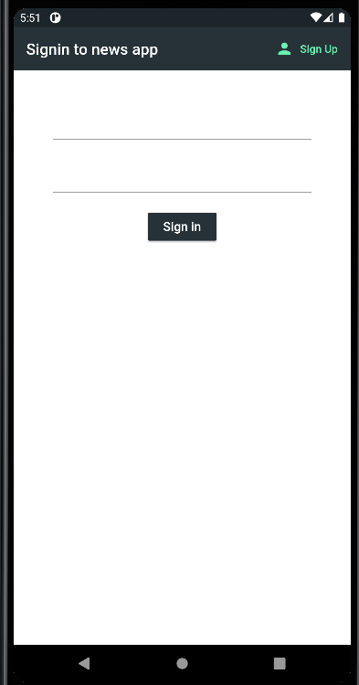

Figure 8.1 Sign-In page

**Homepage**

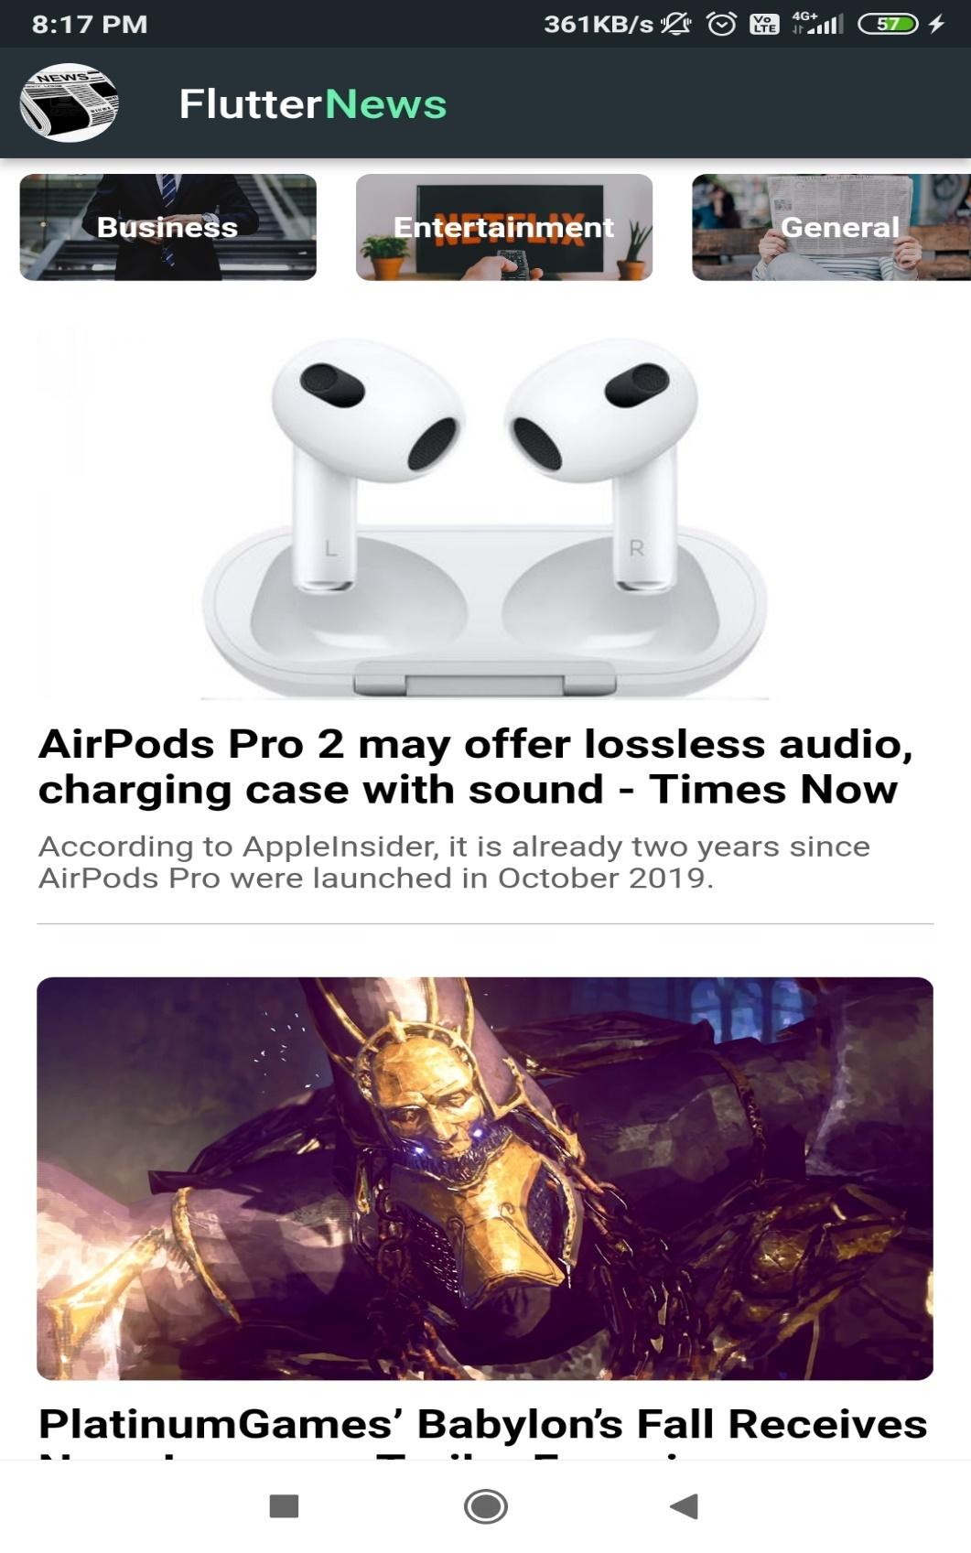

Figure 8.2 Home page

**Healthpage**

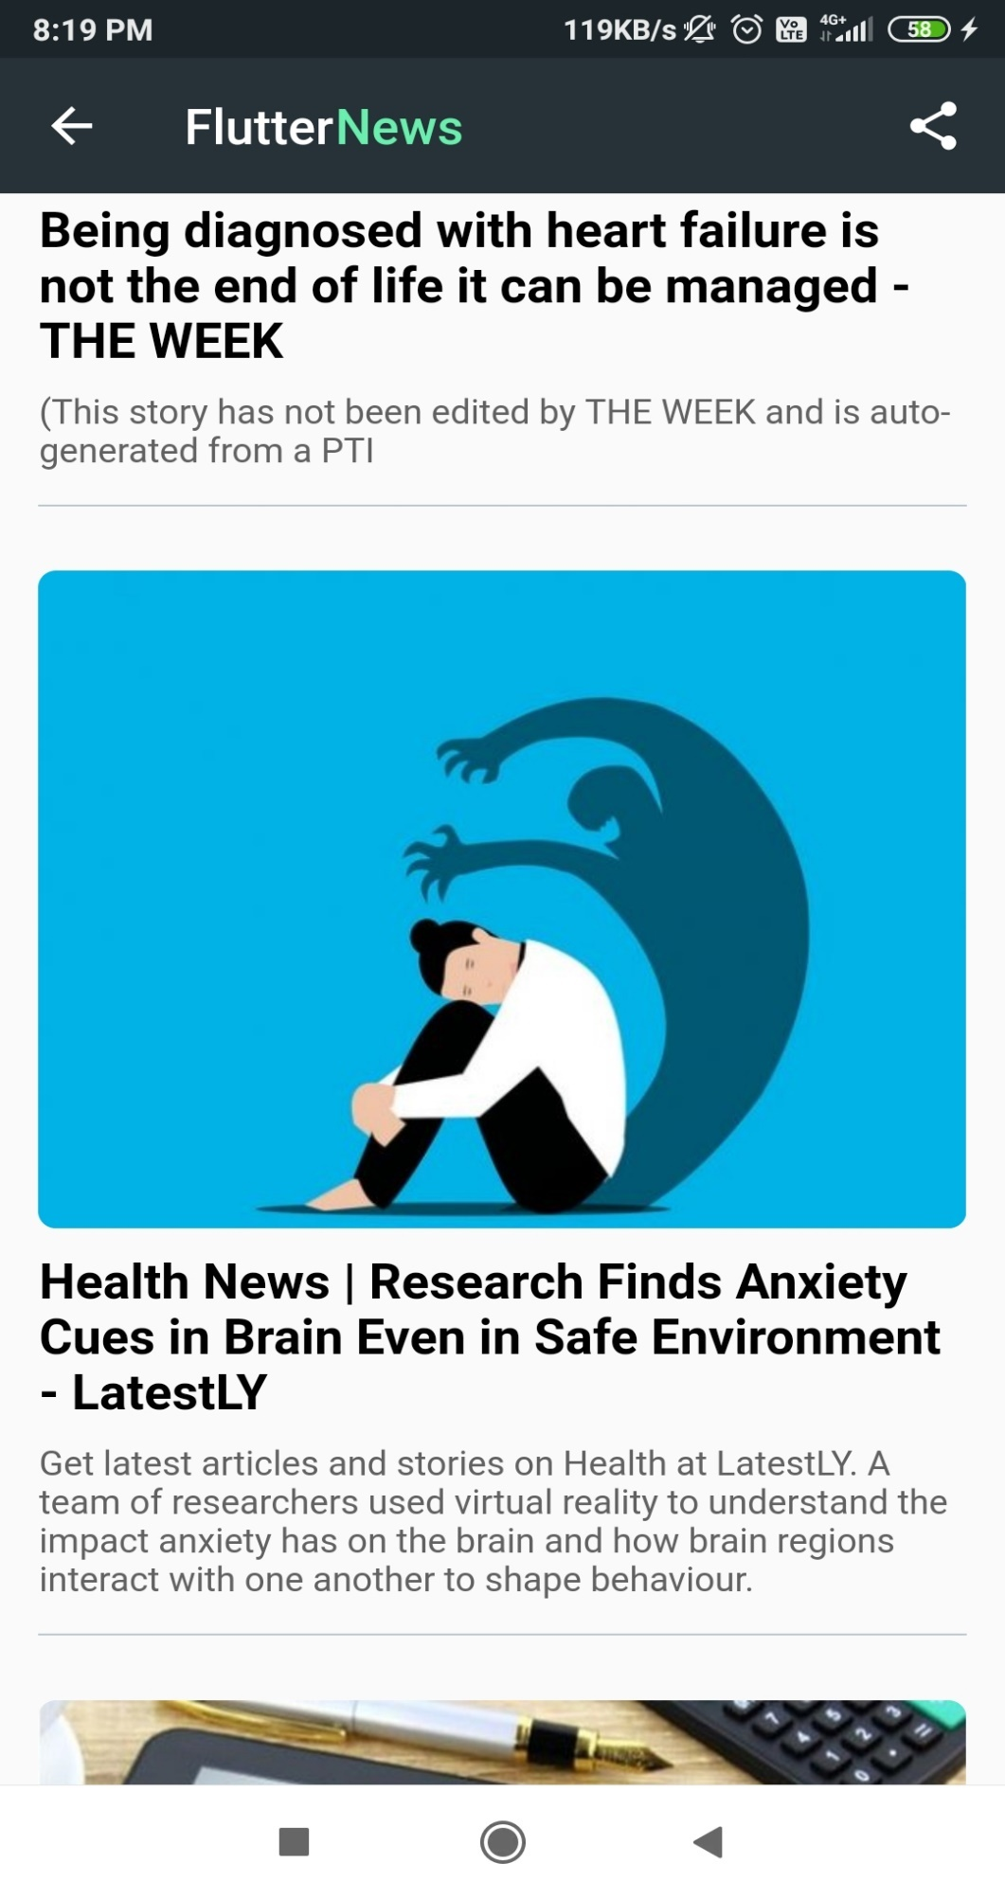

Figure 8.3 Health Page

**Sciencepage**

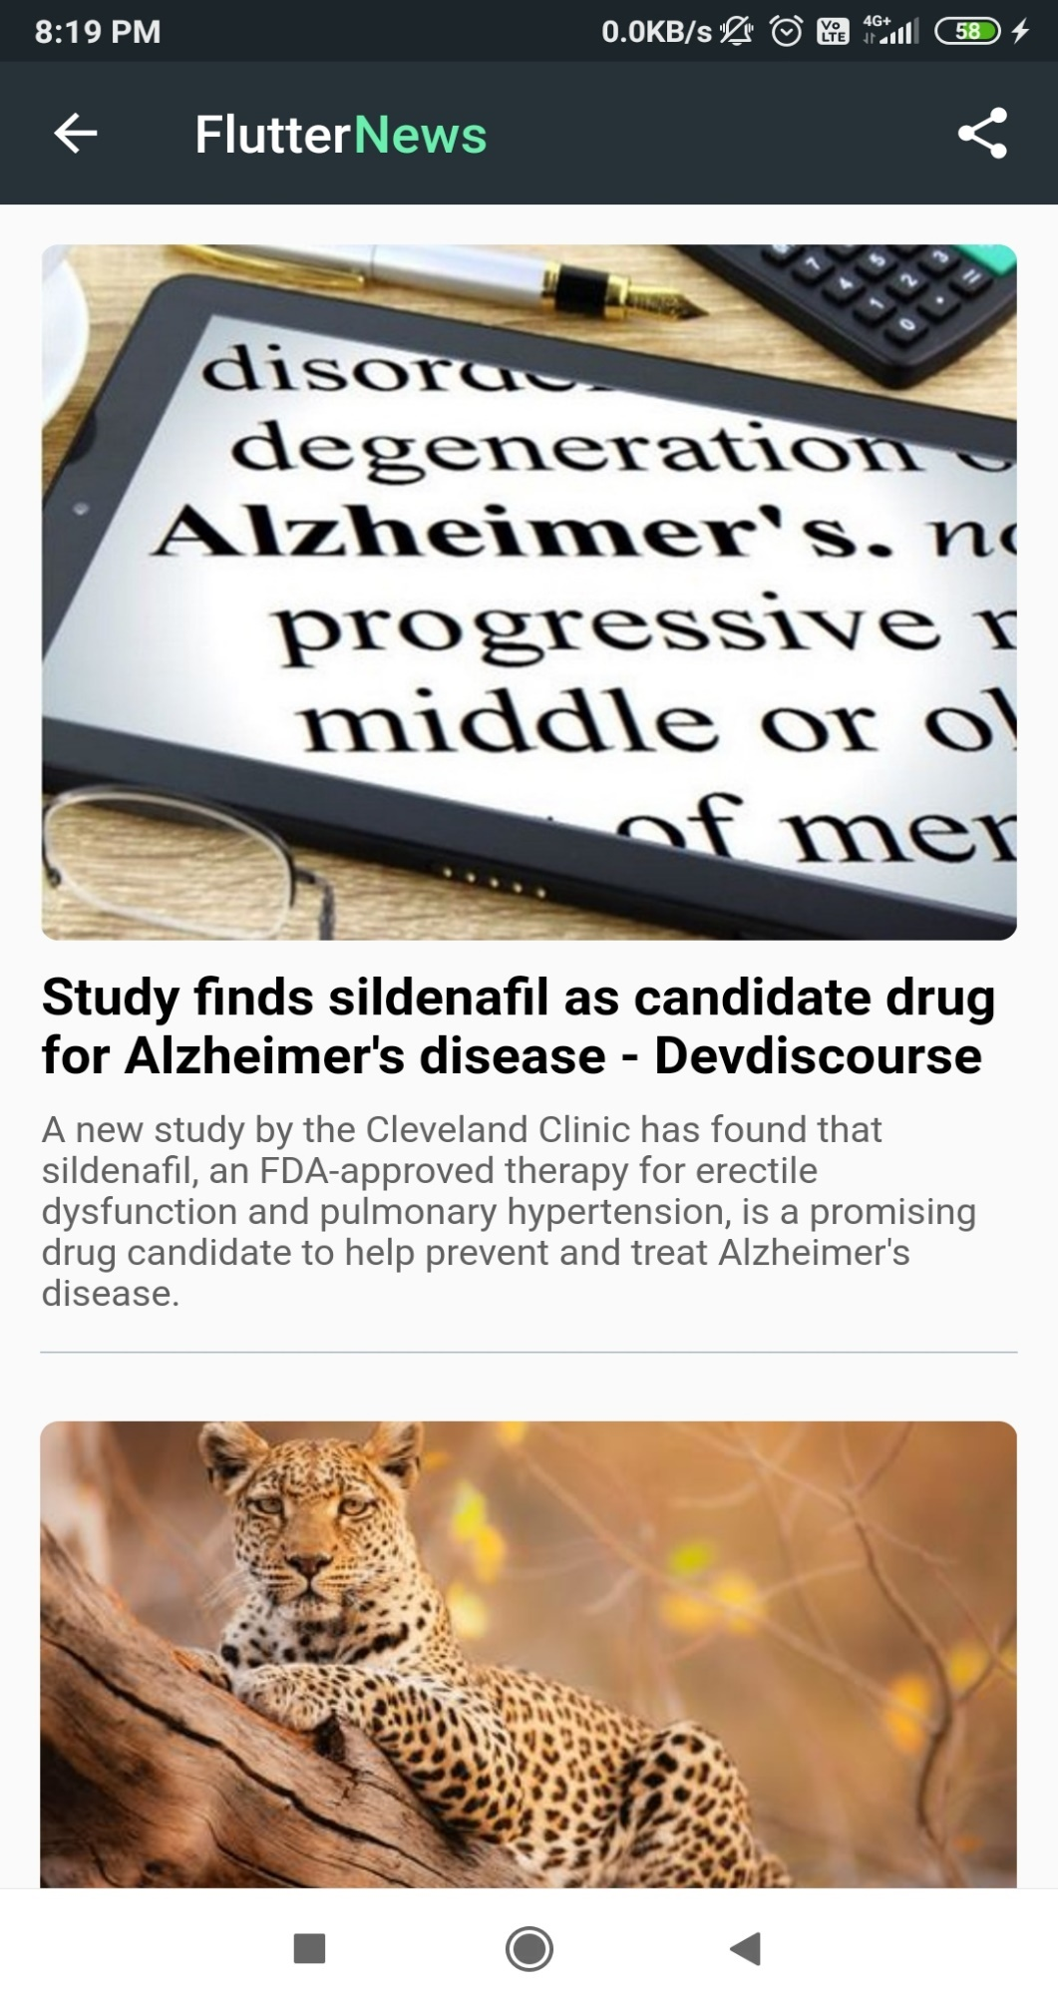

Figure 8.4 Science Page

**Sportspage**

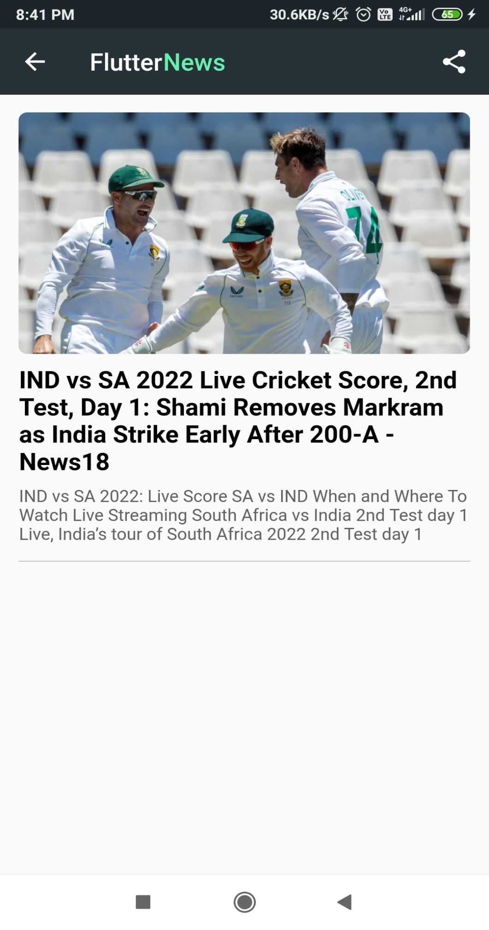

Figure 8.5 Sports Page

**Technologypage**

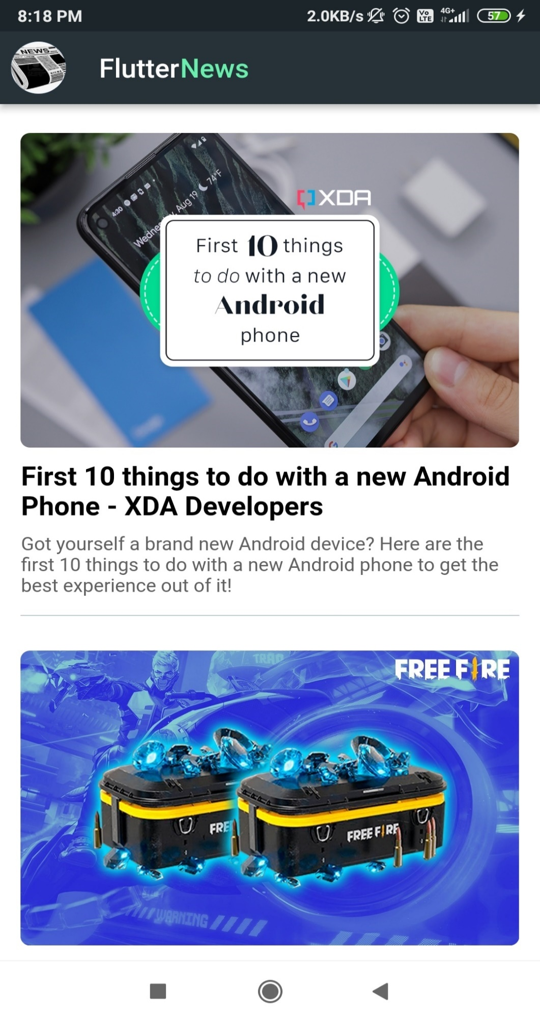

Figure 8.6 Technology Page

**Health Web View**

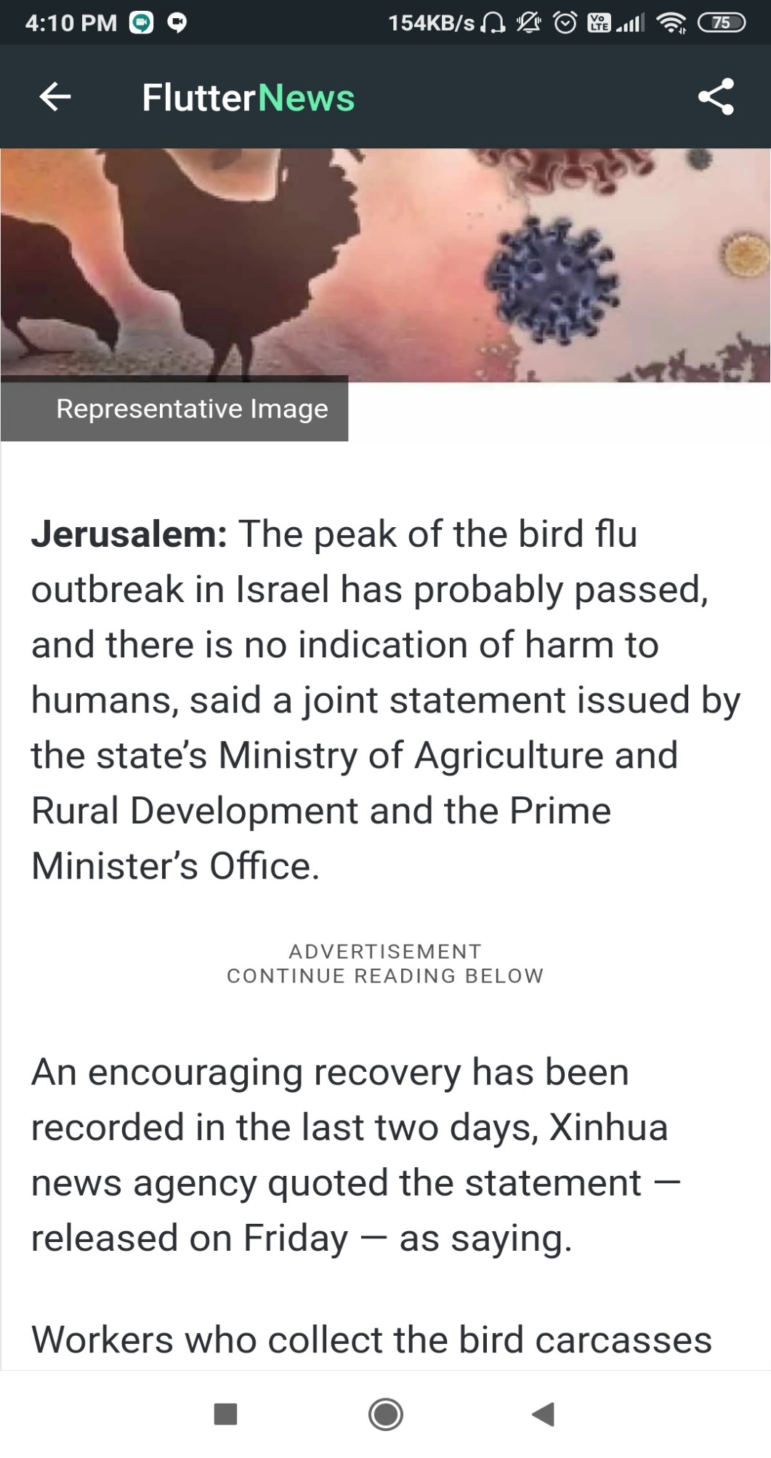

Figure 8.7 Health Web View

**Sports Web View**

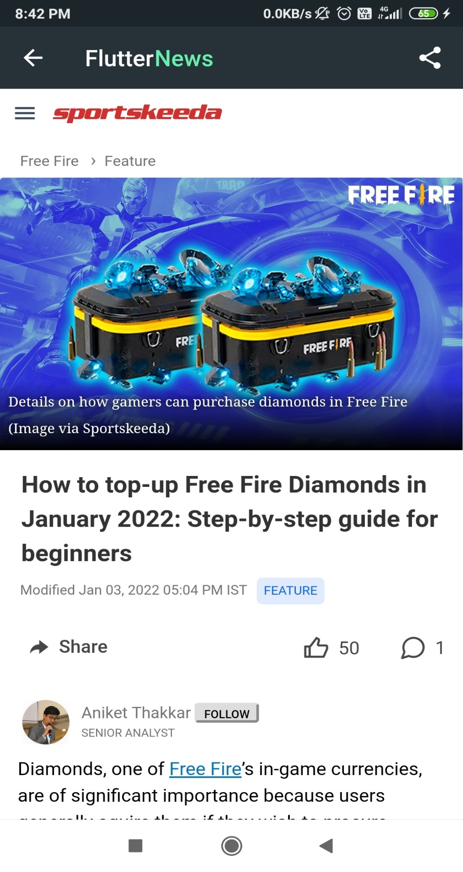

Figure 8.8 Sports Web View

**Entertainment Web View**

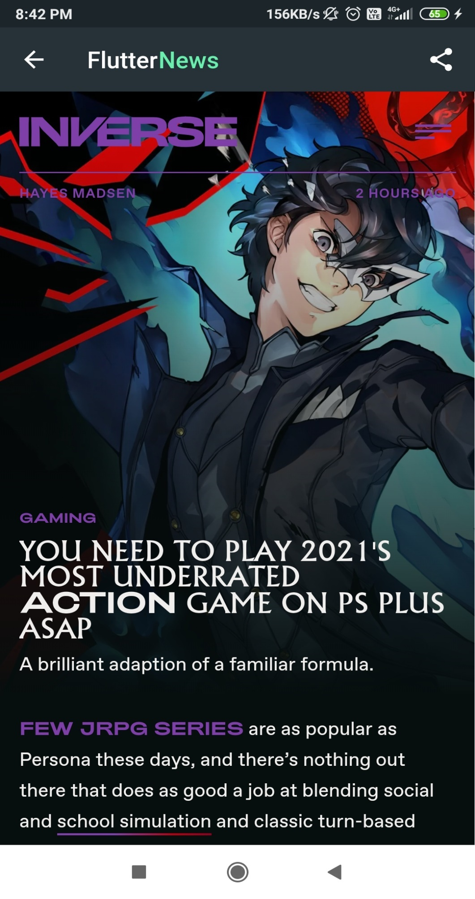

Figure 8.9 Entertainment Web View

# **CHAPTER 9**

# **CONCLUSION AND FUTURE ENHANCEMENT**

News Application is real time application which is currently in use by the end-users to view and get the news at moment.

The application can be enhanced to cover below business scenarios

* Including sorting based on news fame.
* Feature of uploading news.
* Include two factor authorization.
* Ai Ml can used to recommend user’s preferred news.

# **REFERNCES**

* <https://www.studocu.com/in/document/kannur-university/computer-organization/flutter-general-report/11039857>
* Ramez Elmasri and Shamkant B. Navathe, Fundamentals of Database Systems, Pearson, 7th Edition.
* <https://www.irjmets.com/uploadedfiles/paper/volume2/issue_8_august_2020/3180/1628083124.pdf>
* <https://docs.flutter.dev/>
* https://www.tutorialspoint.com/flutter